Equal-Partition Decomposition

Definition
# Source: AI Source: Provided by: [Data Path: Persons Table -> ID Column: 1, Name_En Column: Motasem Essam] -> From: [ChatGPT] on [7/25/2026]
Equal-Partition Decomposition is a method of dividing a geometric figure into two or more regions that have equal area, equal length, or another specified geometric measure. In area-based decomposition, the original figure is partitioned into regions of equal area.
The dividing boundaries may be straight lines, diagonals, medians, grid lines, or other geometric constructions, depending on the figure and the required partition.

Simple Definition
# Source: AI Source: Provided by: [Data Path: Persons Table -> ID Column: 1, Name_En Column: Motasem Essam] -> From: [ChatGPT] on [7/25/2026]
Equal-Partition Decomposition is dividing a geometric figure into smaller parts so that all parts have equal area or satisfy a specified equality condition.
For example, dividing a square into four smaller squares of equal area is an equal-partition decomposition.
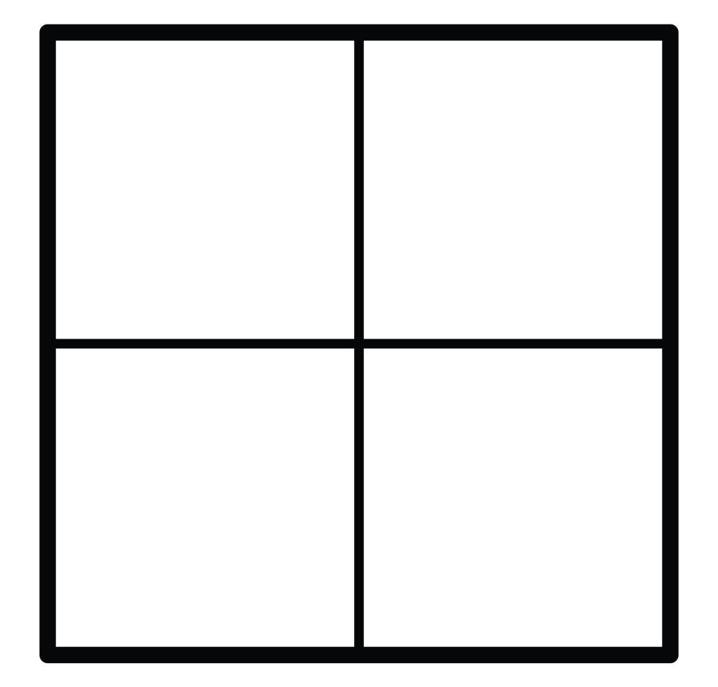
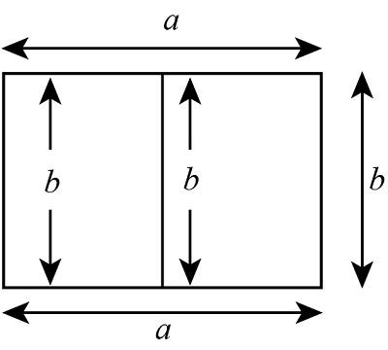
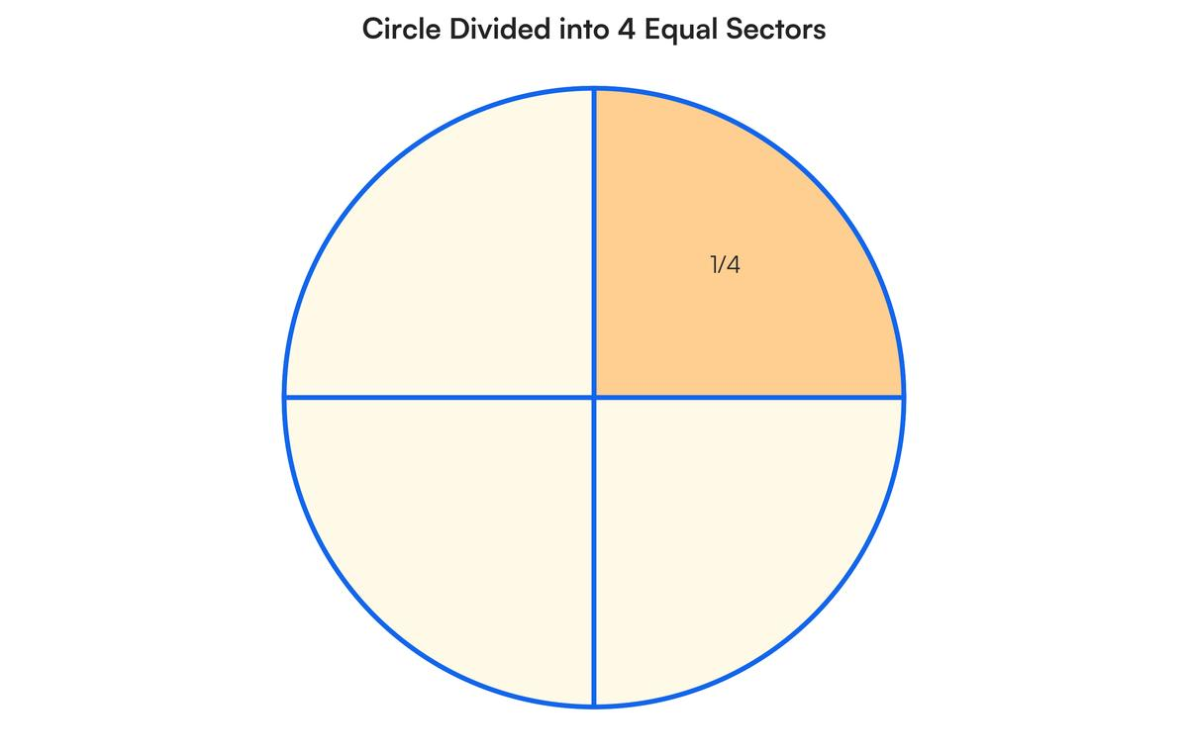

Main Classification
# Source: AI Source: Provided by: [Data Path: Persons Table -> ID Column: 1, Name_En Column: Motasem Essam] -> From: [ChatGPT] on [7/25/2026]
The following is a practical, descriptive classification, rather than a universally standardized mathematical taxonomy. The categories may overlap because a single figure can be divided equally in several different ways.

1. Grid-Based Equal-Partition Decomposition
# Source: AI Source: Provided by: [Data Path: Persons Table -> ID Column: 1, Name_En Column: Motasem Essam] -> From: [ChatGPT] on [7/25/2026]
Divides a figure into equal regions using evenly spaced horizontal and vertical lines.
Example: dividing a square into a $3×3$ grid of nine equal squares.
Detailed Explanation and Examples
Definition: A geometric figure is divided by evenly spaced horizontal and vertical lines to create a grid of equal-area cells.
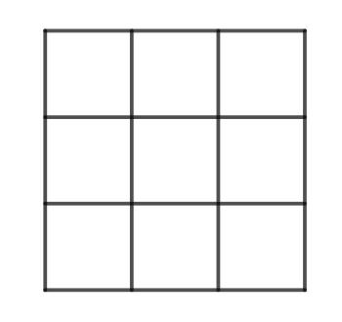
Example:
A square has side length $12$ units. Divide it into a $3×3$ grid.
- Total area:
$$A={12}^{2}=144$$
- Number of equal regions:
$$N=3×3=9$$
- Area of each region:
$$A_{\text{each}}=\frac{144}{9}=16$$
Each small square has side length $4$ units and area $16$ square units.
Important: Equal spacing produces equal areas when the grid cells have the same dimensions.

2. Diagonal-Based Equal-Partition Decomposition
# Source: AI Source: Provided by: [Data Path: Persons Table -> ID Column: 1, Name_En Column: Motasem Essam] -> From: [ChatGPT] on [7/25/2026]
Uses diagonals to divide a figure into regions of equal area.
Example: a rectangle divided by a diagonal into two equal-area triangles.
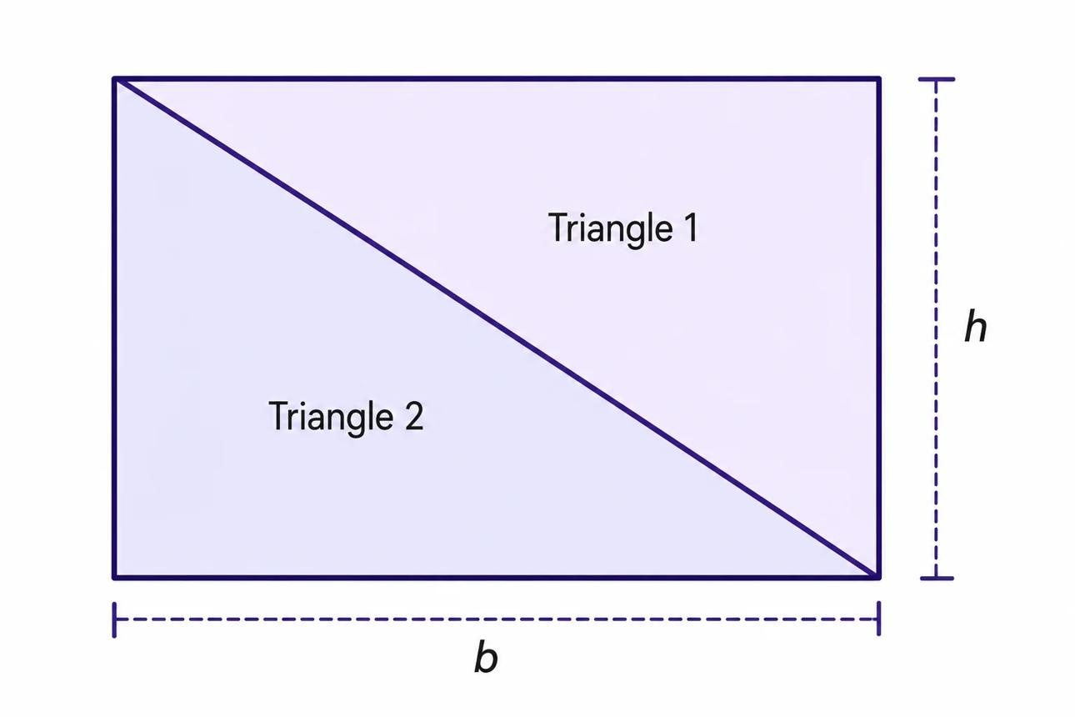
Detailed Explanation and Examples
Definition: A figure is divided using one or more diagonals to create regions of equal area.
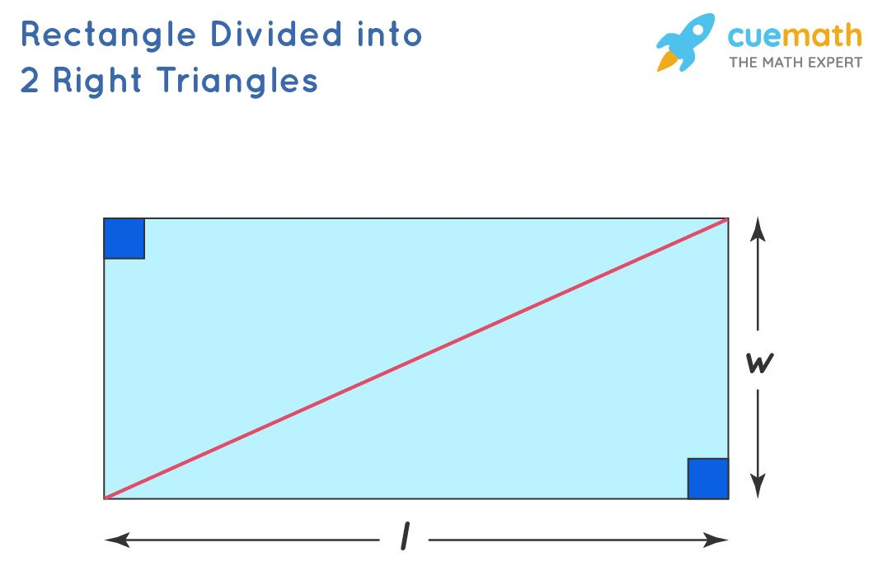
Example:
A rectangle has length $10$ units and width $6$ units. A diagonal divides it into two triangles.
- Rectangle area:
$$A=10×6=60$$
- Area of each triangle:
$$A_{\text{triangle}}=\frac{60}{2}=30$$
The diagonal creates two equal-area triangles, each with area $30$ square units.
Important: The two triangles are congruent in this example. However, equal area alone does not generally guarantee congruence.

3. Median-Based Equal-Partition Decomposition
# Source: AI Source: Provided by: [Data Path: Persons Table -> ID Column: 1, Name_En Column: Motasem Essam] -> From: [ChatGPT] on [7/25/2026]
Uses a median or corresponding midpoint construction to produce equal-area regions.
Example: a triangle divided by a median into two triangles of equal area.
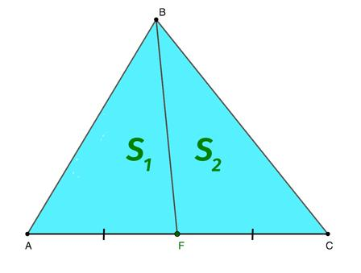
Detailed Explanation and Examples
Definition: A median of a triangle joins a vertex to the midpoint of the opposite side, dividing the triangle into two equal-area triangles.
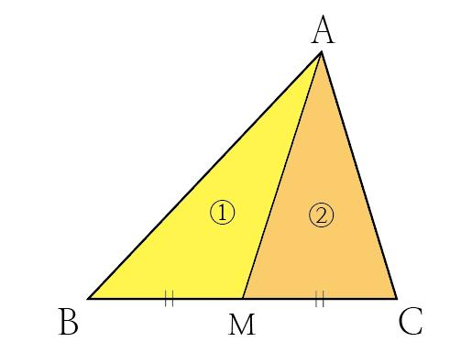
Example:
Triangle $ABC$ has base $BC=12$ units and altitude $AH=5$ units. The median $AD$ meets $BC$ at its midpoint $D$.
$$BD=DC=\frac{12}{2}=6$$
The area of the original triangle is
$$A=\frac{12}{\left(12\right)}\left(5\right)=30$$
Since the two smaller triangles have equal bases along $BC$ and share the same altitude,
$$A_{ABD}=A_{ACD}=\frac{30}{2}=15$$
Each triangle has area $15$ square units.

4. Radial Equal-Partition Decomposition
# Source: AI Source: Provided by: [Data Path: Persons Table -> ID Column: 1, Name_En Column: Motasem Essam] -> From: [ChatGPT] on [7/25/2026]
Divides a circular region into equal sectors using radii from its center.
Example: dividing a circle into six equal sectors, each with a central angle of ${60}^{∘}$.
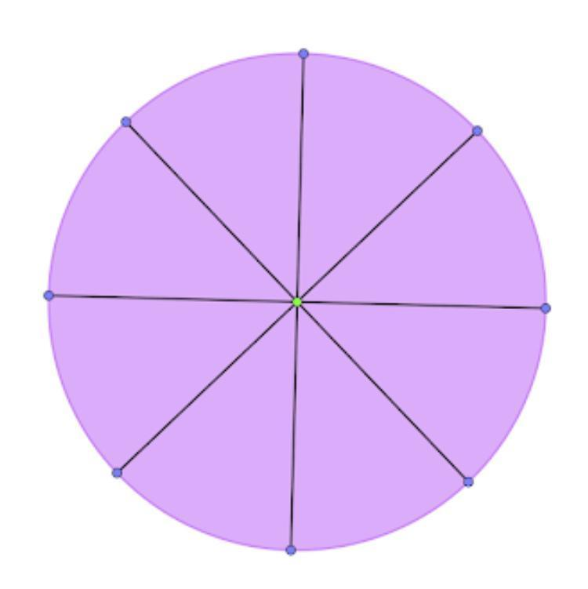
Detailed Explanation and Examples
Definition: A circular region is divided into equal sectors by drawing radii from its center at equal angular intervals.
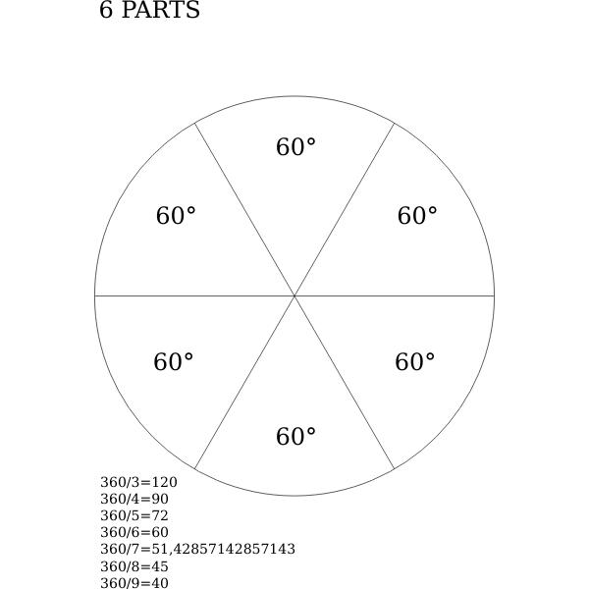
Example:
A circle has radius $6$ units and is divided into six equal sectors.
- Total area:
$$A=π{\left(6\right)}^{2}=36π$$
- Central angle of each sector:
$$θ=\frac{{360}^{∘}}{6}={60}^{∘}$$
- Area of each sector:
$$A_{\text{sector}}=\frac{36π}{6}=6π$$
Each sector has area $6π$ square units.
Important: Equal central angles produce equal-area sectors in the same circle.

5. Center-Based Equal-Partition Decomposition
# Source: AI Source: Provided by: [Data Path: Persons Table -> ID Column: 1, Name_En Column: Motasem Essam] -> From: [ChatGPT] on [7/25/2026]
Connects a central point to boundary points to create equal regions, particularly in regular polygons and centrally symmetric figures.
Example: dividing a regular hexagon from its center into six equal-area triangles.
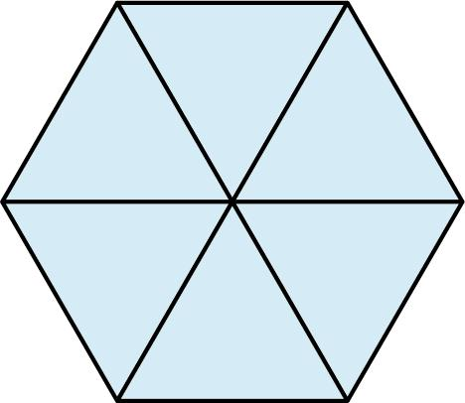
Detailed Explanation and Examples
Definition: A central point is connected to suitable points on a figure's boundary to create equal-area regions.
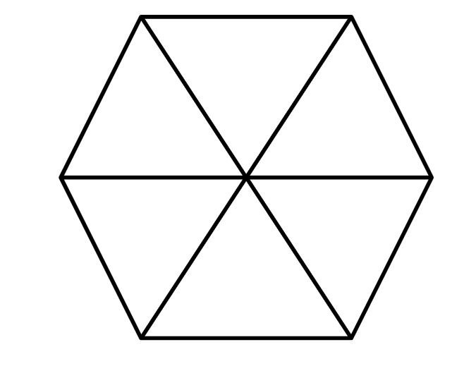
Example:
A regular hexagon has side length $4$ units. Connecting its center to all six vertices produces six congruent equilateral triangles.
The area of each triangle is
$$A_{△}=\frac{\sqrt{3}}{4}{\left(4\right)}^{2}=4\sqrt{3}$$
The total area is
$$A=6\left(4\sqrt{3}\right)=24\sqrt{3}$$
Each of the six regions has area $4\sqrt{3}$ square units.
Important: This construction works particularly well for regular polygons. For an irregular polygon, connecting the center to boundary vertices does not necessarily produce equal-area regions.

6. Strip-Based Equal-Partition Decomposition
# Source: AI Source: Provided by: [Data Path: Persons Table -> ID Column: 1, Name_En Column: Motasem Essam] -> From: [ChatGPT] on [7/25/2026]
Divides a figure into equal-width or equal-area strips.
Example: dividing a rectangle into five horizontal strips of equal area.
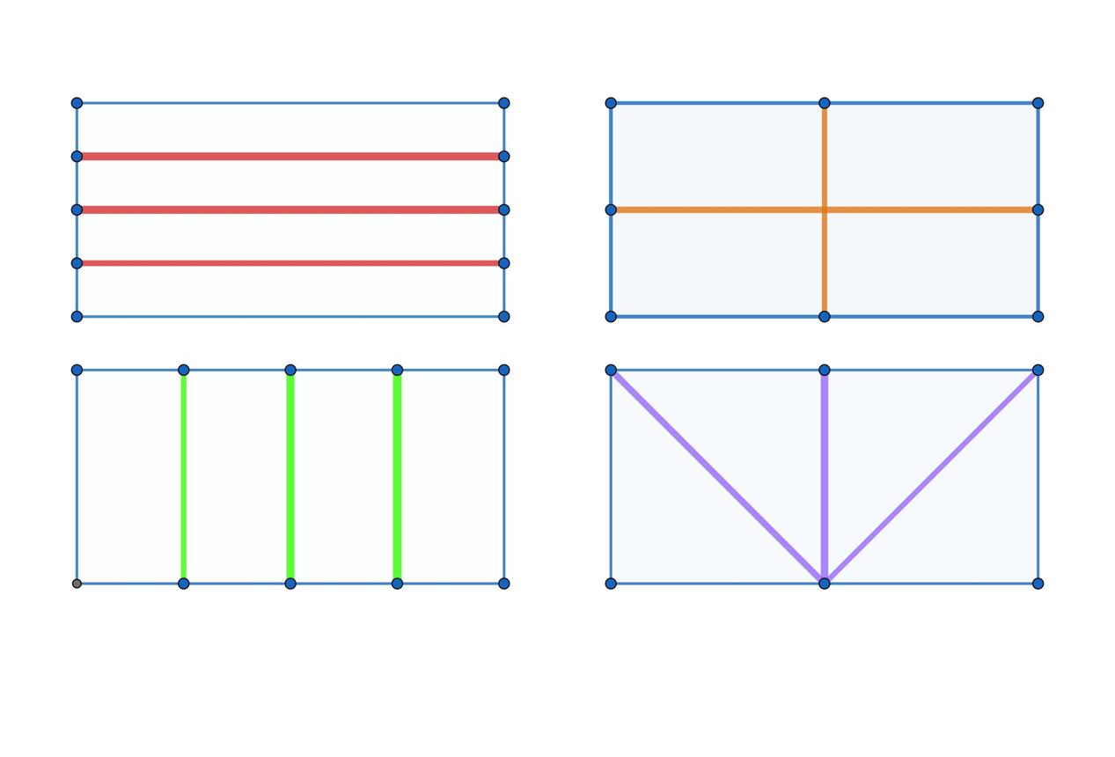
Detailed Explanation and Examples
Definition: A figure is divided into strips that have equal area. The strips may have equal widths when the figure has a suitable uniform shape.
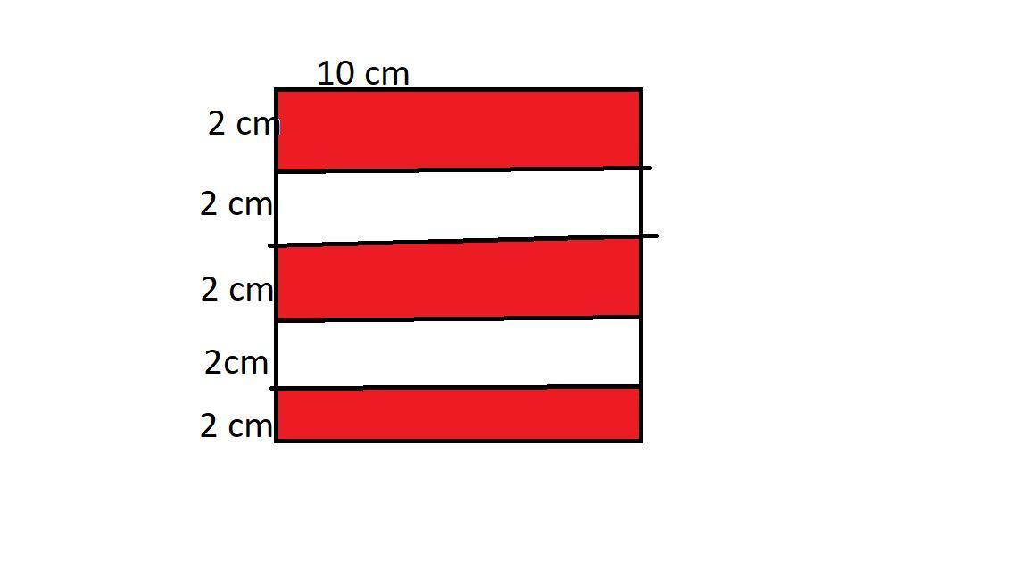
Example:
A rectangle has length $15$ units and width $8$ units. Divide it into five equal horizontal strips, each extending across the full length.
- Total area:
$$A=15×8=120$$
- Area of each strip:
$$A_{\text{strip}}=\frac{120}{5}=24$$
- Width of each strip:
$$w=\frac{85}{5}=1.6$$
Each strip has area $24$ square units.
Important: Equal-area strips do not always have equal widths. For a figure whose width changes along its height, strip boundaries may need to be positioned differently.

7. Equal-Area Decomposition of Irregular Figures
# Source: AI Source: Provided by: [Data Path: Persons Table -> ID Column: 1, Name_En Column: Motasem Essam] -> From: [ChatGPT] on [7/25/2026]
Divides an irregular figure into regions of equal area, even when the regions have different shapes.
Example: partitioning an irregular polygon into three regions, each with area $12$ square units.
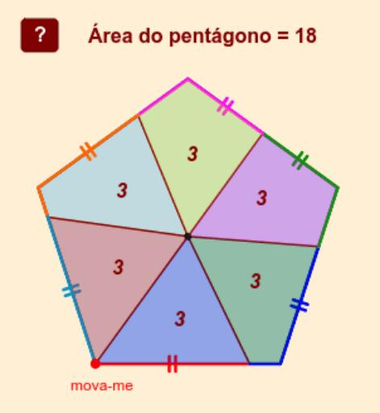
Detailed Explanation and Examples
Definition: An irregular geometric figure is divided into regions of equal area, even if the resulting regions have different shapes.
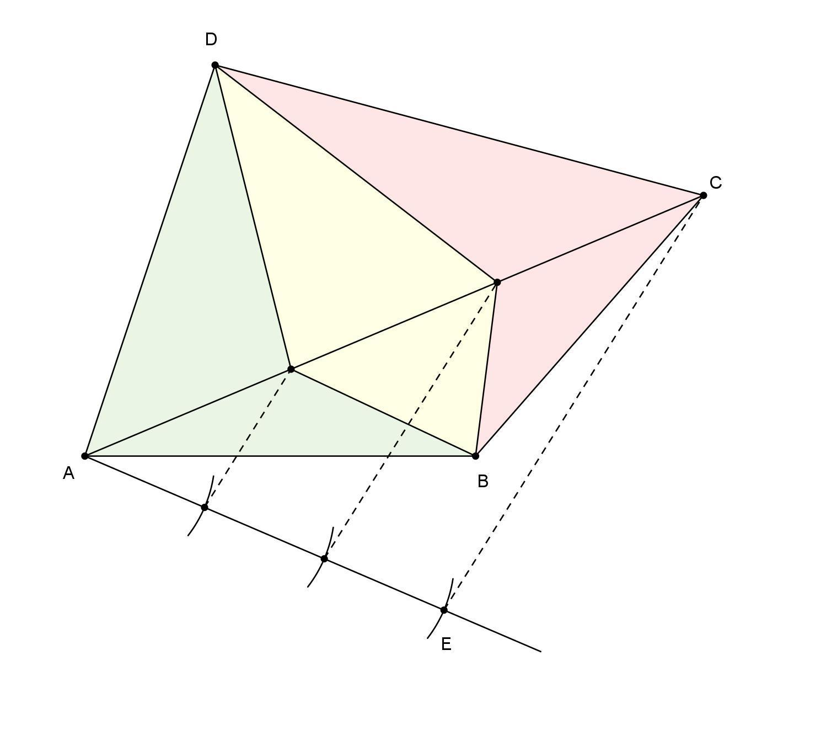
Example:
Suppose an irregular figure has total area $36$ square units and is divided into three regions of equal area.
$$A_{\text{each}}=\frac{36}{3}=12$$
Therefore,
$$A_{1}=A_{2}=A_{3}=12$$
The three regions may have different shapes and perimeters while still having equal areas.
Important: Finding equal-area partitions of irregular figures may require coordinate geometry, area formulas, geometric constructions, or numerical methods.

8. Symmetry-Based Equal-Partition Decomposition
# Source: AI Source: Provided by: [Data Path: Persons Table -> ID Column: 1, Name_En Column: Motasem Essam] -> From: [ChatGPT] on [7/25/2026]
Uses symmetry axes or symmetry-related boundaries to create equal regions.
Example: the two diagonals of a square divide it into four equal-area triangles.

Detailed Explanation and Examples
Definition: A figure's symmetry is used to create regions that correspond under a symmetry transformation and therefore have equal areas.
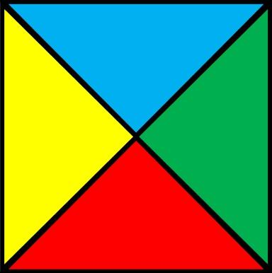
Example:
A square has side length $8$ units. Its two diagonals divide it into four triangles.
- Square area:
$$A=8^{2}=64$$
- Area of each triangle:
$$A_{\text{each}}=\frac{64}{4}=16$$
Each triangle has area $16$ square units.
Important: Symmetry can guarantee equal areas when the regions are mapped onto one another by an area-preserving symmetry. Not every symmetric figure or arbitrary partition automatically gives equal regions.

9. Multiple-Stage Equal-Partition Decomposition
# Source: AI Source: Provided by: [Data Path: Persons Table -> ID Column: 1, Name_En Column: Motasem Essam] -> From: [ChatGPT] on [7/25/2026]
Divides a figure into equal parts in successive stages.
Example: divide a square into four equal squares, then divide each smaller square into four equal squares, producing sixteen equal regions.
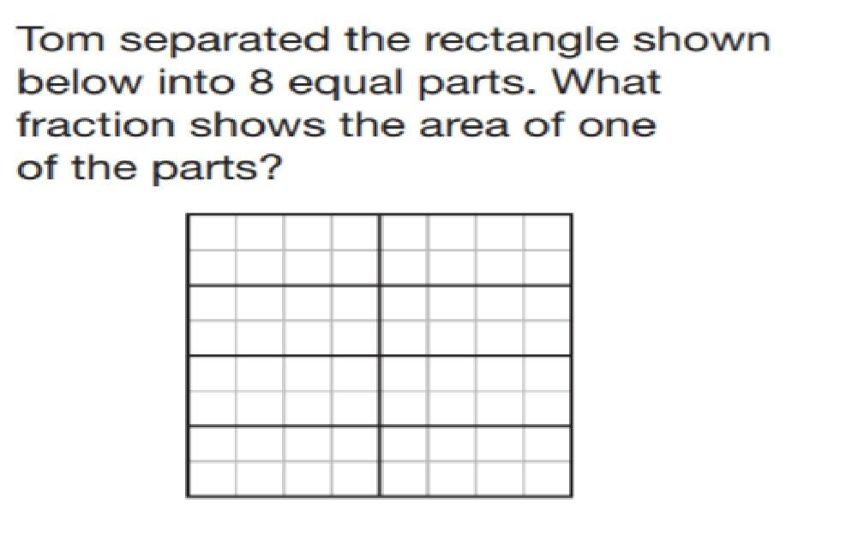
Detailed Explanation and Examples
Definition: A figure is repeatedly divided into equal-area parts, creating progressively smaller regions.
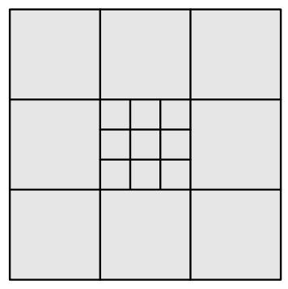
Example:
A square with side length $8$ units is divided into four equal squares. Each smaller square is then divided into four equal squares.
- First stage: $4$ regions.
- Second stage: $4×4=16$ regions.
- Original area:
$$A=8^{2}=64$$
- Area of each final region:
$$A_{\text{each}}=\frac{64}{16}=4$$
Each final square has area $4$ square units and side length $2$ units.
For a process with $k$ stages, where each region is divided into $m$ equal-area parts at every stage, the number of final regions is
$$N=m^{k}$$
provided the same subdivision rule is applied to every region at each stage.

Key Formulas
# Source: AI Source: Provided by: [Data Path: Persons Table -> ID Column: 1, Name_En Column: Motasem Essam] -> From: [ChatGPT] on [7/25/2026]
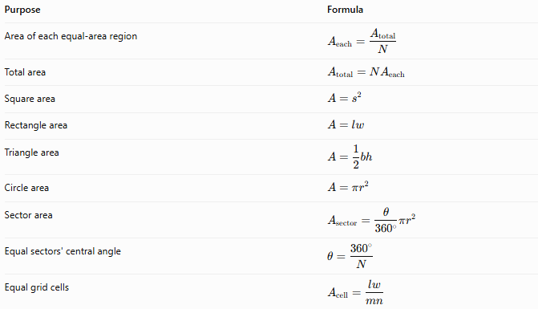
Purpose | Formula
Area of each equal-area region | $$A_{\text{each}}=\frac{A_{\text{total}}}{N}$$
Total area | $$A_{\text{total}}=NA_{\text{each}}$$
Square area | $$A=s^{2}$$
Rectangle area | $$A=lw$$
Triangle area | $$A=\frac{1}{2}bh$$
Circle area | $$A=πr^{2}$$
Sector area | $$A_{\text{sector}}=\frac{θ}{{360}^{∘}}πr^{2}$$
Equal sectors' central angle | $$θ=\frac{{360}^{∘}}{N}$$
Equal grid cells | $$A_{\text{cell}}=\frac{lw}{mn}$$
For the grid formula, $m$ is the number of columns and $n$ is the number of rows in a rectangular grid of a rectangle with length $l$ and width $w$.

Equal Partition vs. Other Decomposition Types
# Source: AI Source: Provided by: [Data Path: Persons Table -> ID Column: 1, Name_En Column: Motasem Essam] -> From: [ChatGPT] on [7/25/2026]
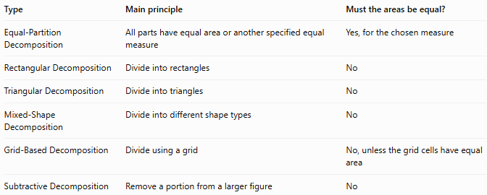
Type | Main principle | Must the areas be equal?
Equal-Partition Decomposition | All parts have equal area or another specified equal measure | Yes, for the chosen measure
Rectangular Decomposition | Divide into rectangles | No
Triangular Decomposition | Divide into triangles | No
Mixed-Shape Decomposition | Divide into different shape types | No
Grid-Based Decomposition | Divide using a grid | No, unless the grid cells have equal area
Subtractive Decomposition | Remove a portion from a larger figure | No
Important distinction: Equal-area partitioning does not necessarily mean equal-shape partitioning. Two regions can have the same area but different shapes, side lengths, and perimeters.

Classification Summary
# Source: AI Source: Provided by: [Data Path: Persons Table -> ID Column: 1, Name_En Column: Motasem Essam] -> From: [ChatGPT] on [7/25/2026]
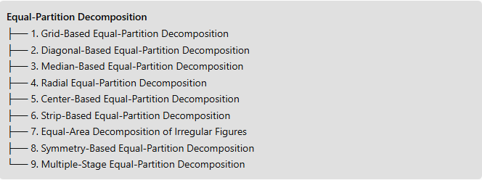
Equal-Partition Decomposition
├── 1. Grid-Based Equal-Partition Decomposition
├── 2. Diagonal-Based Equal-Partition Decomposition
├── 3. Median-Based Equal-Partition Decomposition
├── 4. Radial Equal-Partition Decomposition
├── 5. Center-Based Equal-Partition Decomposition
├── 6. Strip-Based Equal-Partition Decomposition
├── 7. Equal-Area Decomposition of Irregular Figures
├── 8. Symmetry-Based Equal-Partition Decomposition
└── 9. Multiple-Stage Equal-Partition Decomposition

Key Points
# Source: AI Source: Provided by: [Data Path: Persons Table -> ID Column: 1, Name_En Column: Motasem Essam] -> From: [ChatGPT] on [7/25/2026]
- Equal-partition decomposition divides a figure into parts satisfying a common measure, most commonly equal area.
- The number and shape of the regions depend on the figure and the construction method.
- Equal areas do not imply equal shapes, equal perimeters, or congruence.
- Symmetry, medians, diagonals, radial lines, and grids are useful ways to create equal-area partitions.
- A correct decomposition must cover the intended figure without unintended gaps or overlaps.

Conclusion
# Source: AI Source: Provided by: [Data Path: Persons Table -> ID Column: 1, Name_En Column: Motasem Essam] -> From: [ChatGPT] on [7/25/2026]
Equal-Partition Decomposition is a geometric decomposition method in which a figure is divided into regions of equal area or another specified equal measure. It can be achieved through grids, diagonals, medians, radial divisions, symmetry, strips, or repeated subdivision. Its central requirement is equality of the chosen measure, not necessarily equality of the regions' shapes.

